Skill/Job Recommender Application Problem Statements

|  |  |
| --- | --- |
| Date | 10 NOVEMBER 2022 |
| Team ID | PNT2022TMID18116 |
| Project Name | Skill/Job Recommender Application |

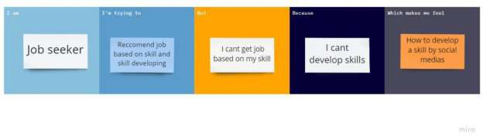

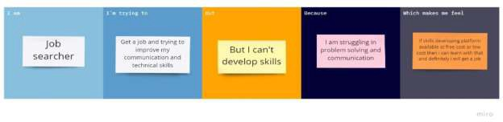

|  |  |  |  |  |  |
| --- | --- | --- | --- | --- | --- |
| Problem Statement (PS) | I am (User) | I’m trying to | But | Because | Which makes me feel |
| PS-1 | I am a | I want to | I can’t get | I need more | How to |
|  | Job | improve my | a job | training in | develop |
|  | Seeker | personal skill | without | communication | skill by |
|  |  | and technical | personal | part | visiting |
|  |  | skill | and |  | many |
|  |  |  | technical |  | websites |
|  |  |  | skills |  |  |

|  |  |  |  |  |  |
| --- | --- | --- | --- | --- | --- |
| PS-2 | I am a Job Seeker | Improve my problem solving skills | I will face more problem if I lack problem solving skills | I want to manage real time problems in working environment | If a skill developing platform available at free of cost or low cost then I will get the training and will be  placed |